INSTITUTE OF AERONAUTICAL ENGINEERING

# (Autonomous)

Dundigal, Hyderabad - 500 043

# Student Details

Format for Field Practicum (FP) Report

|  |  |
| --- | --- |
| Name of the Student | 1. Suresh |
| Roll Number | 21955A0112 |
| Department | CIVIL |
| Year / Semester | 2nd / 4th |
| Mobile Number | 6304676146 |
| Email ID | [Sureshangothu20@gmail.com](mailto:Sureshangothu20@gmail.com) |

# Mentor Details

|  |  |
| --- | --- |
| Name of the Mentor | 1. Bhavani |
| Organization | Institute of aeronautical engineering |
| Designation | Assistant professor |
| Email ID | Bbhavani@iare.ac.in |
| Mobile Number | 7674024526 |

1. Title of the ﬁeld practicum

“A STUDY OF CONSTRUCTION OF CEMENT CONCRETE ROAD, NANDI MEDARAM, PEDDAPALLI”

1. **Purpose of the ﬁeld project**

* To know the construction of the roads
* Roads are important assets for any nation
* Each type of pavement has its own merits and demerits.

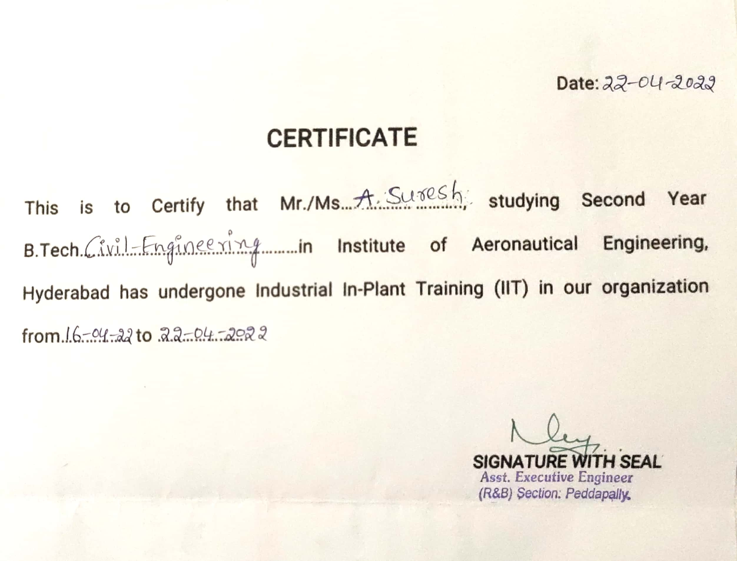

1. **Objectives**

Development of a country depends on the connectivity of various places with adequate road network. Roads are the major channel of transportation for carrying goods and passengers. They play a significant role in improving the socio-economic standards of a region. Roads constitute the most important mode of communication in areas where railways have not developed much and form the basic infra-structure for the development and economic growth of the country.

The benefits from the investment in road sector are indirect, long-term and not immediately visible. Roads are important assets for any nation. However, merely creating these assets is not enough, it has to be planned carefully and a pavement which is not designed properly deteriorates fast.

India is a large country having huge resource of materials. If these local materials are used properly, the cost of construction can be reduced. There are various type of pavements which differ in their suitability in different environments.

Each type of pavement has its own merits and demerits. Despite a large number of seminars and conference, still in India, 98% roads are having flexible pavements. A lot of research has been made on use of Waste materials but the role of these materials is still limited. So there is need to take a holistic approach and mark the areas where these are most suitable.

India has one of the largest road networks in the world (over 3 million km at present).For the purpose of management and administration, roads in India are divided into the following five categories: 4

1. National Highways (NH)
2. State Highways (SH)
3. Major District Roads (MDR)
4. Other District Roads (ODR)
5. **Description of the practicum**

Pavement or Road is an open, generally public way for the passage of vehicles, people, and animals. Pavement is finished with a hard smooth surface. It helped make them durable and able to withstand traffic and the environment. They have a life span of between 20 – 30 years. 6 Road pavements deteriorate over time due to-

• The impact of traffic, particularly heavy vehicles.

• Environmental factors such as weather, pollution.

PURPOSE

Many people rely on paved roads to move themselves and their products rapidly and reliably.

FUNCTIONS

• One of the primary functions is load distribution. It can be characterized by the tire loads, tire configurations, repetition of loads, and distribution of traffic across the pavement, and vehicle speed.

• Pavement material and geometric design can affect quick and efficient drainage. These eliminating moisture problems such as mud and pounding (puddles). Drainage system consists of: ¬ Surface drainage: Removing all water present on the pavement surface, sloping, chambers, and kerbs. ¬ Subsurface drainage: Removing water that seep into or is contained in the underlying sub-grade.

TYPES OF PAVEMENTS

* FLEXIBLE PAVEMENTS

Bitumen has been widely used in the construction of flexible pavements for a long time. This is the most convenient and simple type of construction. The cost of construction of single lane bituminous pavement varies from 20 to 30 lakhs per km in plain areas.

* RIGID PAVEMENTS

Rigid pavements, though costly in initial investment, are cheap in long run because of low maintenance costs.

INTRODUCTION:

The various materials used in PLAIN CONCRETE OR SHORT PAVEMENT SLABS

1. CEMENT
2. AGGREGATE

**1. CEMENT:**

 Cement is a binder, a substance that sets and hardens independently, and can bind other materials together. The word "cement" traces to the Romans, who used the term caementicium to describe masonry resembling modern concrete that was made from crushed rock with burnt lime as binder. The volcanic ash and pulverized brick additives that were added to the burnt lime to obtain a hydraulic binder were later referred to as cementum, cimentum, cement, and cement. Cements used in construction can be characterized as being either hydraulic or non-hydraulic. Hydraulic cements (e.g., Portland cement) harden because of hydration, a chemical reaction between the anhydrous cement powder and water. Thus, they can harden underwater or when constantly exposed to wet weather.

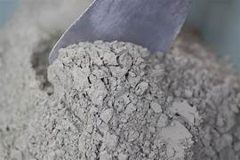 

**Fig 1: NAGARJUNA CEMENT**

**2.AGGREGATES**

 Aggregates are inert granular materials such as sand, gravel, or crushed stone that, along with water and Portland cement, are an essential ingredient in concrete. For a good concrete mix, aggregates need to be clean, hard, strong particles free of absorbed chemicals or coatings of clay and other fine materials that could cause the deterioration of concrete.

Aggregates, which account for 60 to 75 percent of the total volume of concrete, are divided into two distinct categories-fine and coarse. Fine aggregates generally consist of natural sand or crushed stone with most particles passing through a 3/8-inch (9.5-mm) sieve. Coarse aggregates are any particles greater than 0.19 inch (4.75 mm), but generally range between 3/8 and 1.5 inches (9.5 mm to 37.5 mm) in diameter. Gravels constitute the majority of coarse aggregate used in concrete with crushed stone making up most of the remainder.

Natural gravel and sand are usually dug or dredged from a pit, river, lake, or seabed. Crushed aggregate is produced by crushing quarry rock, boulders, cobbles, or large-size gravel. Recycled concrete is a viable source of aggregate and has been satisfactorily used in granular sub bases, soil-cement, and in new concrete.

Aggregate processing consists of crushing, screening, and washing the aggregate to obtain proper cleanliness and gradation. If necessary, a benefaction process such as jigging or heavy media separation can be used to upgrade the quality. Once processed, the aggregates are handled and stored in a way that minimizes segregation and degradation and prevents contamination. Aggregates strongly influence concrete's freshly mixed and hardened properties, mixture proportions, and economy. Consequently, selection of aggregates is an important process. Although some variation in aggregate properties is expected, characteristics that are considered when selecting aggregate include:

• grading

• durability

• particle shape and surface texture

• abrasion and skid resistance

• unit weights and voids

• absorption and surface moisture

Grading refers to the determination of the particle-size distribution for aggregate. Grading limits and maximum aggregate size are specified because grading and size affect the amount of aggregate used as well as cement and water requirements, workability.

**FINE AGGREGATES**

 Fine aggregate shall consist of sand, or sand stone with similar characteristics, or combination thereof. It shall meet requirements of the State Department of Transportation of Uttar Pradesh , Section 501.3.6.3 of the Standard Specifications for Highway and Structure Construction, current edition.

**COARSE AGGREGATES**

 Coarse aggregate shall consist of clean, hard, durable gravel, crushed gravel, crushed boulders, or crushed stone. It shall meet the requirements of the State Department of Transportation of Uttar Pradesh , Section 501.3.6.4 of the Standard Specifications for Highway and Structure Construction, current edition.

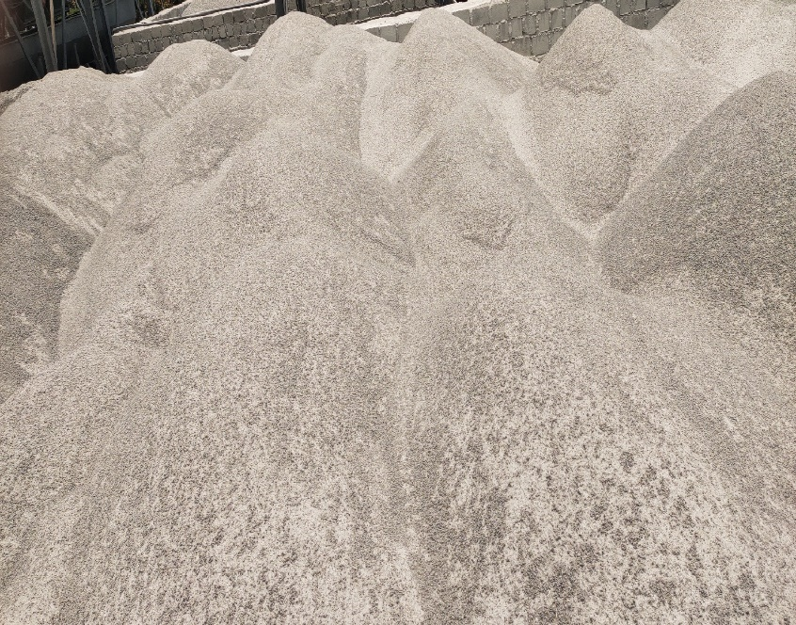

**Fig 2: ROBO SAND**

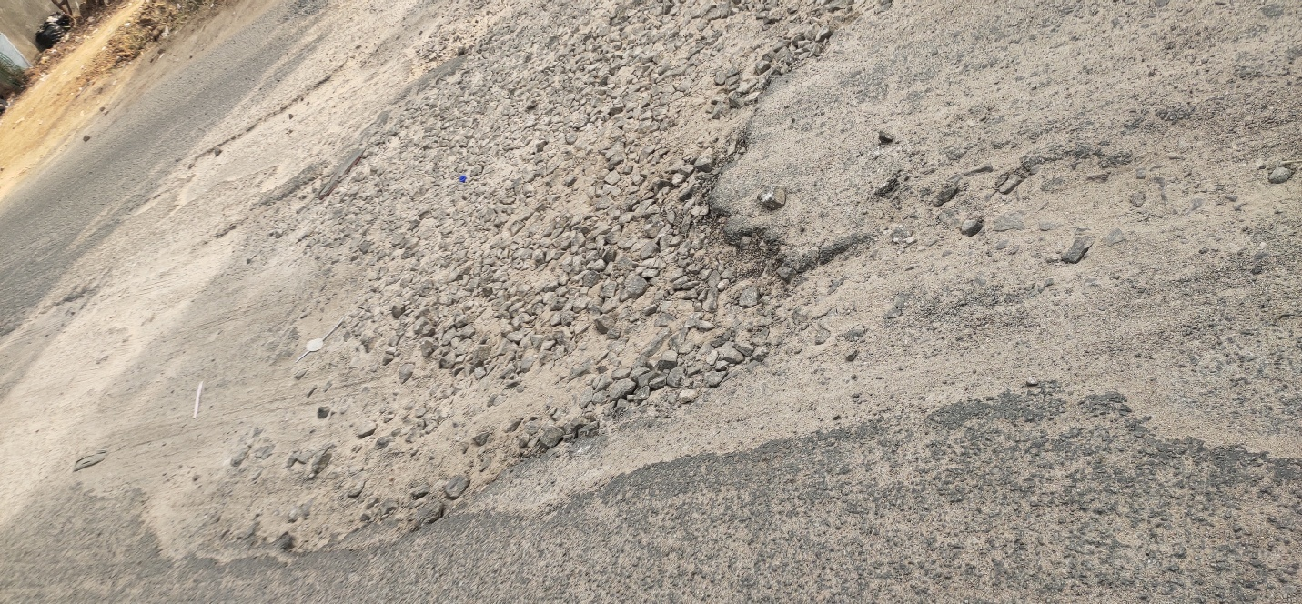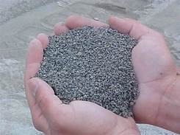 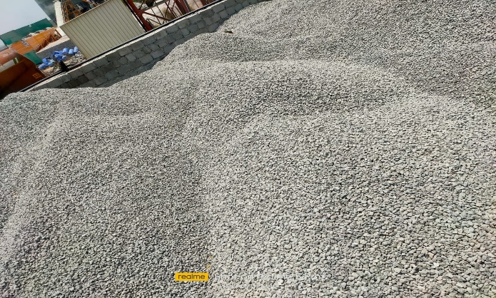

**Fig 3:COARSE AGGREGATE**

**PROCEDURE TO CONSTRUCT PAVEMENTS**

During construction of a cement concrete pavement, various steps are taken as below-

• Survey of proposed work is done by experienced engineers or by any expert of survey, site survey includes geographical details, soil properties and site investigation.

• After survey , a team of experienced engineers and architecture prepare detailed plan of work with the help of various soft ware's.

• After that a engineer prepares detailed estimate of proposed work and also prepares a estimate regarding equipments required and labours requirements.

• Now excavation is done with the help of automatic machines and then a equipment is used to cut nearby trees and root removal process.

• After these construction of soil sub grade , base coarse and then construction of 13 concrete slab is done.

**PREPARATION OF THE SUB- GRADE OR BASE COARSE**

The road sub grade has to be prepared carefully, in order to realize everywhere a pavement structure of an adequate and uniform thickness. This allows to provide a homogeneous bond between the concrete slab and its foundation which is important for the later behaviour of the pavement structure. For roads with a base, drainage of the water must be provided. Mud, leaves, etc. have to be removed. When the base is permeable, it should be sprayed with water in order to prevent the mixing water from being sucked out of the concrete. However, if the base is impermeable (e.g. if the concrete is placed on a watertight asphalt concrete interlayer) it can be necessary under warm weather conditions to cool down this layer by spraying water on the surface. The following points are important for roads without a foundation:

• Drainage of all surface water;

• Good compaction of the sub grade;

• Filling and compaction of any ruts caused by construction traffic;

• It is forbidden to level the sub grade by means of a course of sand. If the sub grade has to be levelled, it is advisable to do this by using a granular material: either slag or coarse aggregate e.g. with a grain size 0/20;

• Provide an additional width of the sub grade for more lateral support. It must always be avoided that water is sucked from the cement paste into the substructure or the base. This can be accomplished by either moderately moistening the sub grade, or by applying a plastic sheet on the substructure of the pavement. The latter work must be done with care, to prevent the sheet from tearing or being pulled loose by the wind.

**MIXING AND TRANSPORT OF CONCRETE MIXING PLANT**

 The concrete mixing plant must have a sufficient capacity in order to be able to continuously supply concrete to the paving machines. The mix constituents and admixtures have to be dosed very accurately. The number of aggregate feed bins has to equal at least the number of different aggregate fractions. The bins shall have raised edges to prevent contamination of the aggregate fractions. The equipment for loading the materials shall be in good condition and shall have sufficient capacity to be able to continuously feed the bins. The bucket of the loaders shall not be wider than the bins. The content of the cement silos and the water tank are in proportion to the production rates. For small works, permanent concrete mixing plants are often called on. In that case, mixing plants that are inspected and that can deliver Indian quality certification concrete should be used. Furthermore it is useful and even essential to have a communication system between the concrete mixing plant and the construction site in order to coordinate the batching and paving operations.

**TRANSPORT OF THE CONCRETE**

 Sufficient trucks must be available to continuously supply the paving machines. The number depends on the yield at the construction site, the loading capacity of the trucks and the cycle time (i.e. the transport time plus the time required to load and unload a truck).

The loading capacity and the type of truck to be used depend on the nature of the work, the haul roads and the concrete paving machines. Usually, the specifications prescribe that the concrete has to be transported in dump trucks as paving concrete consists of a relatively dry mix having a consistency that makes transport and unloading in truck mixers difficult. Furthermore, dump trucks can discharge the concrete faster.

For small works and in urban areas, the use of truck mixers is increasingly accepted. Under these circumstances an admixture (e.g. a superplastisizer) can be mixed in just before discharging the concrete. The necessary measures have to be taken to prevent changes of the water content and temperature of the concrete during transport. To this end, the specifications prescribe to cover the dump trucks by means of a tarpaulin.

**PLACING THE CONCRETE**

Usually the concrete is placed using slip form paving machines which applies for all categories of roads. This equipment meets both the requirements for quality and for the envisaged rate of production. Conventional concreting trains riding on set up rails, are hardly used any more for roadworks in our country. For this reason this manner of execution will not be dealt with here. However, the technique of manually placing the concrete using forms is still applied in certain cases, such as for the construction of roundabouts with a small diameter, at intersections, for repair work or when the execution conditions are such that slip form pavers cannot be utilized. This occurs increasingly often in urban areas for the construction of pavement surfaces of exposed aggregate and possibly coloured concrete

**EXECUTION OF JOINTS**

 All the equipment that is necessary to make joints in the fresh or hardened concrete must be present at the construction site. The saw blades have to be suitable to the quality of the concrete, i.e. to the hardness and the abrasion resistance of the aggregates. It is useful to have spare equipment available in case of a defect. The beam for making a construction joint shall be rigid and shall allow the realization of a straight joint perpendicular to the axis of the road. This beam has to be adapted to the type of pavement (jointed pavement, continuously reinforced concrete pavement)

1. TRANSVERSE JOINTS
2. CONTRACTION JOINTS

Crack onsets are executed to avoid uncontrolled (“wild”) cracking of the concrete by shrinkage. Contraction joints have a crack onset which extends to a depth of one third of the slab thickness and can be equipped with dowels. On main roads, the contraction joints are usually made by sawing. The saw cutting should occur as soon as possible, usually between 5 and 24 hours after placement of the concrete. It is obvious that the concrete should have hardened sufficiently in order to prevent the edges of the joint from being damaged.

In case of high temperatures, special equipment is available to execute saw cutting within 3 hours subsequent to the placement of the concrete. In that case, light equipment is used to make saw cuts of about 2.5 cm deep. Every saw cut that has not instigated a crack within 24 hours is deepened up to 1/3 of the slab thickness. Making crack onsets for contraction joints in the fresh concrete is a technique that is practically no longer applied except for country roads or municipal roads whenever the traffic intensity and evenness requirements permit so. To make such a joint, a thin steel blade (no more than 6 mm thick) is vibrated into the fresh concrete to a depth of 1/3 of the slab thickness.

The joint can be made both with flexible and with rigid joint strips. In the first method, a thin plastic strip twice as wide as the depth of the crack point plus 2 cm is laid on the fresh concrete. The steel blade is positioned in the middle of the strip and is subsequently vibrated into the fresh concrete. In the second method the rigid joint strip is inserted into a groove priory made by vibrating the steel blade in the concrete. The top of the strip must be flush with the pavement surface. After having made the crack onset, the concrete surface along the joint should be smoothened again. However, manual corrections should be kept to a minimum as much as possible, since they can cause spalling of the joint edges later.

**EXPANSION JOINTS**

 Expansion joints are only used exceptionally. In these rare cases, they have to meet the necessary requirements so as not to cause difficulties later. The execution of expansion joints requires special attention when using slip form paving machines. Special attention shall be paid to the following:

• the wooden joint filler board shall be firmly attached to the base by means of metal stakes, so that it cannot move while the concrete is being placed;

• the height of the joint filler board shall be slightly(2 to 3 cm) shallower than the thickness of the concrete slab, in order not to hinder the placement of the concrete. As soon as the slip form paving machine has passed, the concrete above the joint filler board shall be removed over a width at least equal to the thickness of the board, so that no “concrete arch” is made at the top of the joint;

• expansion joints shall always be provided with dowels, even for roads with less intense traffic. At one end of each dowel a cap filled with a compressible material accommodates the movements of the concrete.

1. **CONSTRUCTION JOINTS**

Construction joints also called end-of-day or working joints - are made at the end of the daily production or when the paving process is interrupted for at least 2 hours. The face of these joints is plane, vertical and perpendicular to the axis of the pavement. They are always doweled. Upon resuming the paving the fresh concrete is placed against the concrete that has already hardened. The concrete is consolidated on both sides of the joint with a separate manual needle vibrator.

**LONGITUDINAL JOINTS**

Longitudinal joints run parallel to the axis of the road and are only necessary if the pavement is wider than 4.5m. They can be provided with tie bars.

1. **LONGITUDINAL CONTRACTION / BENDING JOINTS**

These joints are realized between adjacent concrete lanes that are executed simultaneously. They are saw cut in the hardened concrete, no later than 24 hours after the concrete has been placed. The depth is at least 1/3 of the thickness of the slab.

1. **LONGITUDINAL CONSTRUCTION JOINTS**

These are joints between two adjacent concrete lanes that are executed successively.

**CURING**

Curing is the process of increasing hydration in cement; after setting the concrete, curing process is done till 20 to 25 days. 19 There are some method of curing-

• Shading concrete works

• Covering with hessian & gunny bags

• Sprinkling of water

• By ponding

• Membrane curing

 COST ANALYSIS OF RIGID PAVEMENTS

The selection criteria of type of pavement, flexible or rigid, should be based not on the initial cost of construction but life cycle cost, which includes the discounted maintenance and pavement strengthening costs that are incurred during the design life of the pavement.

1. **INITIAL COST**

This is the cost of construction of the pavement which mainly depends upon the pavement thickness, governed by the strength of sub grade soil and traffic loading, cost of materials and cost of execution of the work. the above have a wide range of variability across the country and is difficult to generalize.

**2.MAINTENANCE COST**

The maintenance cost includes the maintenance of pavement during the design life of pavement to keep the pavement at the specified service level. In case of rural roads, maintenance of these roads is to be done by the respective state government from its available financial resources. most of the states have poor past performance record to maintain such low volume roads through other schemes, mainly because of having inadequate funds for maintenance of road infrastructure in the state.

**LIFE CYCLE COST ANALYSIS**

Life cycle cost analysis can be defined as a procedure by which a pavement design alternative will be selected , which will provide a satisfactory level of service at the lowest cost design life.

**RIGID PAVEMENT DESIGN AND COSTOF CONSTRUCTION PER KILOMETERS**

The design of rigid pavement depends upon the CBR value of sub grade , design axle load of commercial vehicles during the design life, which is generally 20 years or more for rural roads, a typical pavement composition for rural road is given below :( refer: SP:62-2004):

**MAINTENANCE COST OF RIGID PAVEMENT**

The average yearly maintenance cost of rigid pavement will be about Rs. 10000per km for a single lane rural road to cover filling of sealing compound in the joints, requires of concrete spalling etc.

**LIFE CYCLE COST ANALYSIS OF RIGID PAVEMENT**

Period of analysis has been considered as 20 years, being the design life of concrete pavement in rural area. The discount rate of 10% has been taken. Inflation rate of 5% has been considered for future rise in prices of materials.



**Fig 4: OBSERVING SUB BASE**

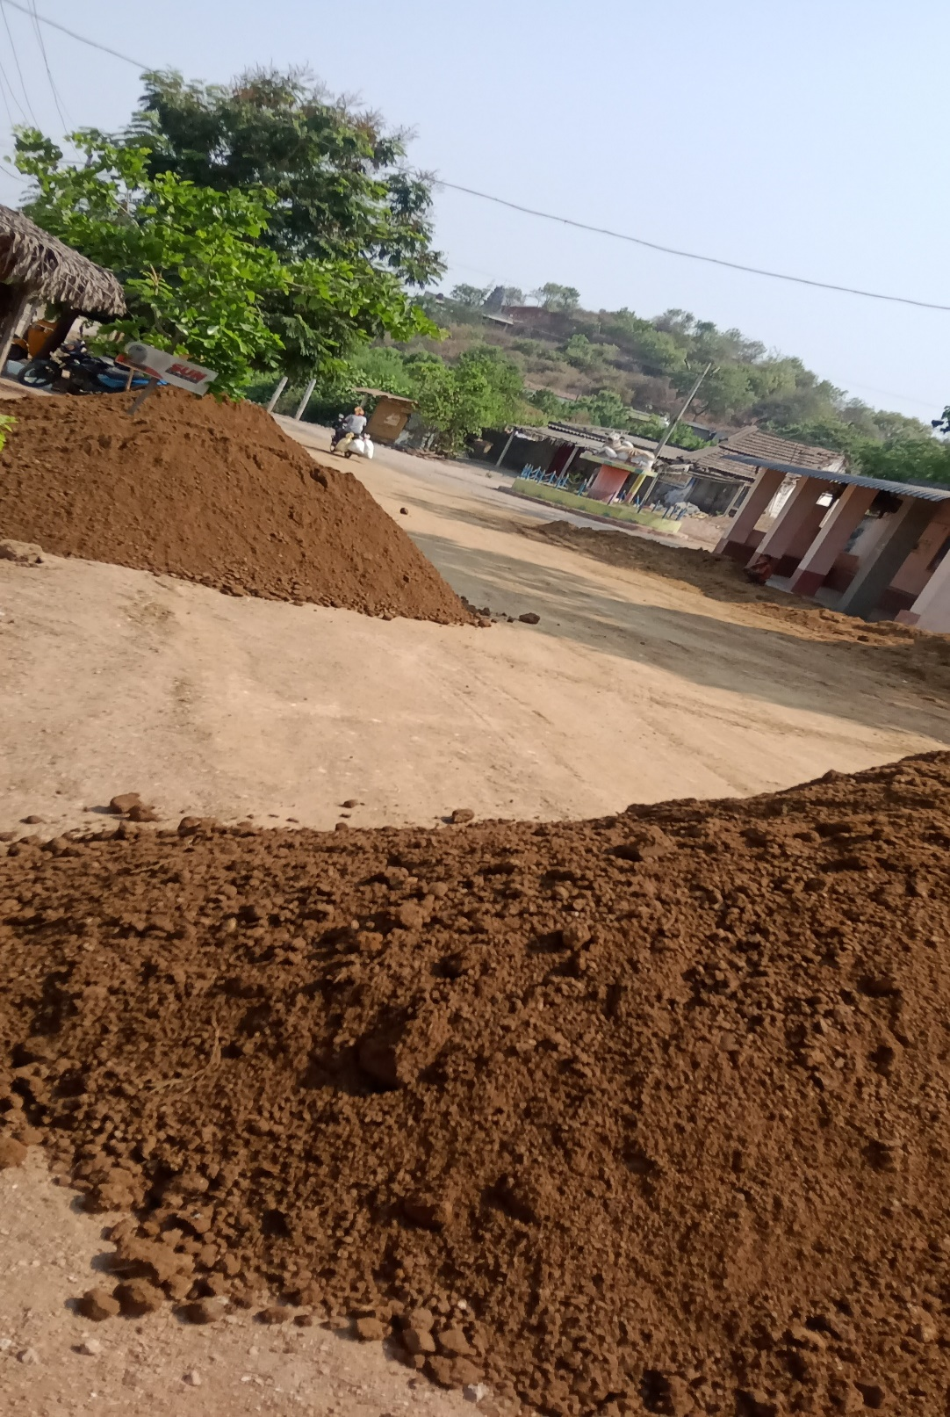

**Fig 5:GRAVEL SPREDING**

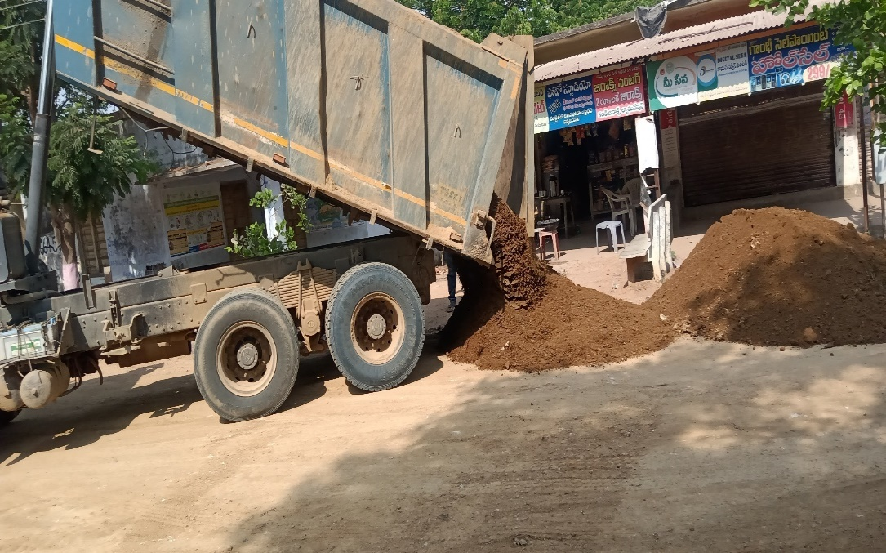

**Fig 6:GRAVEL PLACING WITH HELP OF TIPPER**

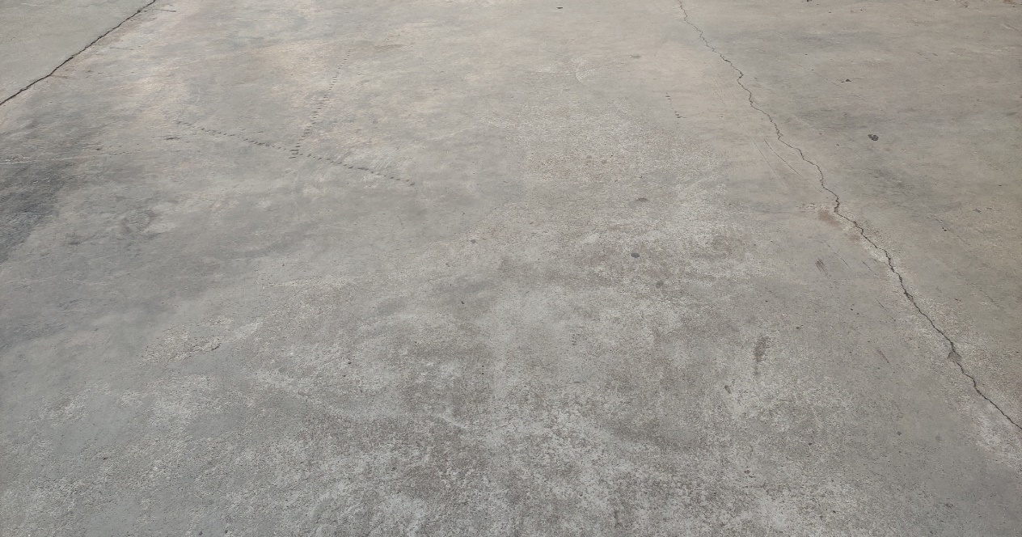

**Fig 8: CEMENT CONCRETE ROAD**

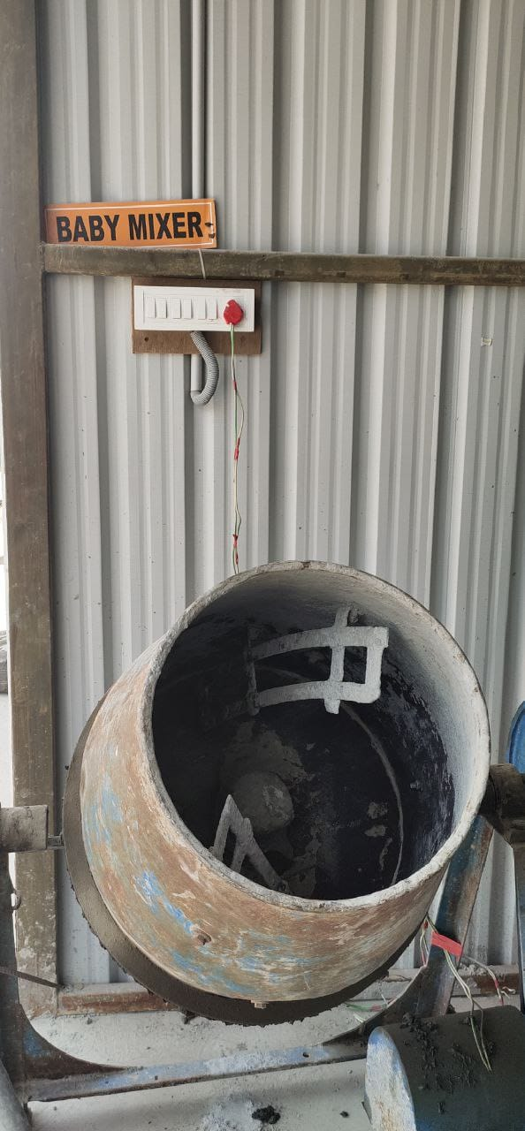

**Fig 7:MIXER**

**CONCLUSION:**

* Concrete roads are good roads but not cheaper roads. These roads should be considered only if sufficient funds are available.
* The thickness of the pavement and the reinforcement should not be compromised. Semi Rigid pavements should be constructed in nearby areas of steel plants where these materials are available free of cost.
* In this regard, Government may pass an ordinance for compulsory use of these materials in such areas. Bitumen is going to more costly in future. So it should be used very judiciously. Modification like CR, EVA and SBS may be used to reduce the susceptibility of the bitumen. It will reduce the quantity of bitumen also.

**Signature of the Student Signature of the Mentor**

**Signature of the Head of the Department with Seal**